Works of Mercy Prayer and Reflection Resources for Mercy Day
A series of brief reflections on 7 of the 15 Works of Mercy
(which could be offered during ‘Mercy Week’ e.g. via your Intranet, a daily briefing or at the start of a meeting)
Short reflections on a selection of Works of Mercy
As part of a daily briefing or as an item uploaded on the organization’s Intranet each day leading up to Mercy Day, a work of mercy can be chosen as the focus for that day. Using the link below to the Works of Mercy on the MIA website:
https://www.mercyworld.org/about/works-of-mercy/
You are invited to engage with a different work of mercy each day. The following are suggested:
- Sept 17: Sheltering the homeless
- Sept 18: Instructing the ignorant
- Sept 19: Visiting the sick
- Sept 20: Consoling the afflicted
- Sept 21: Counselling the doubtful
- Sept 22: Feeding the hungry
- Sept 23: Caring for our common home
- Sept 24: Celebrating Mercy Day (see suggestion below)
The following process may be helpful:
- Take time to view the sketch. Identify what is happening and, if you can, locate yourself somewhere in the sketch.
- Click on the ‘Behind the scene’ tab beneath the sketch and ponder the situation at the time when Clare Agnew was sketching her experience of what the Sisters were doing.
- Read the brief comment about the Work of Mercy in practice in our own time.
- Bring to mind some ways in which this particular work of mercy is being done in your workplace today.
- Express gratitude in some way for the gift of this work of mercy in your own life.

Suggestion for Mercy Day, September 24
Introduction
Every year, around this time of the feast day of Our Lady of Mercy on September 24, as members of the Mercy family around the world, we take time to reflect on our identity and purpose and to celebrate the rich heritage handed down through our founders.
The first House of Mercy commenced at Baggot Street in Dublin on this day in 1827. In 2021, in a letter dated September 24, the feast of Our Lady of Mercy, Mercy Ministry Companions (MMC) received its official approval from Rome as a Ministerial Public Juridic Person (MPJP).
The MMC timeline, which includes significant founding or commencement dates for the ministries within MMC and the other MPJPs in Australia and Aotearoa New Zealand, reflects a rich history of Mercy ministry. Take the opportunity to find the significant dates for your ministry sites shown in the timeline. MMC Timeline
Reading
In writing about mercy and compassion, Wendy Farley, as American theologian, says that:
“…compassion (mercy) is a mode of relationship
and a power
that is wounded by the suffering of others
and propelled to action on their behalf
now.
Mercy is a mode of relationship, not a momentary, sporadic feeling. It is rather, a habit of mind and heart, a way of organizing and interpreting the world. It is an enduring approach to the world. And, like any relationship, it is a two-way street.”
Farley, Wendy, cited in Patricia Smith (1994), ‘Mercy values today: ever ancient, ever new’ in Morning and Evening Prayer of the Sisters of Mercy, pp. 932-933

Work of Mercy
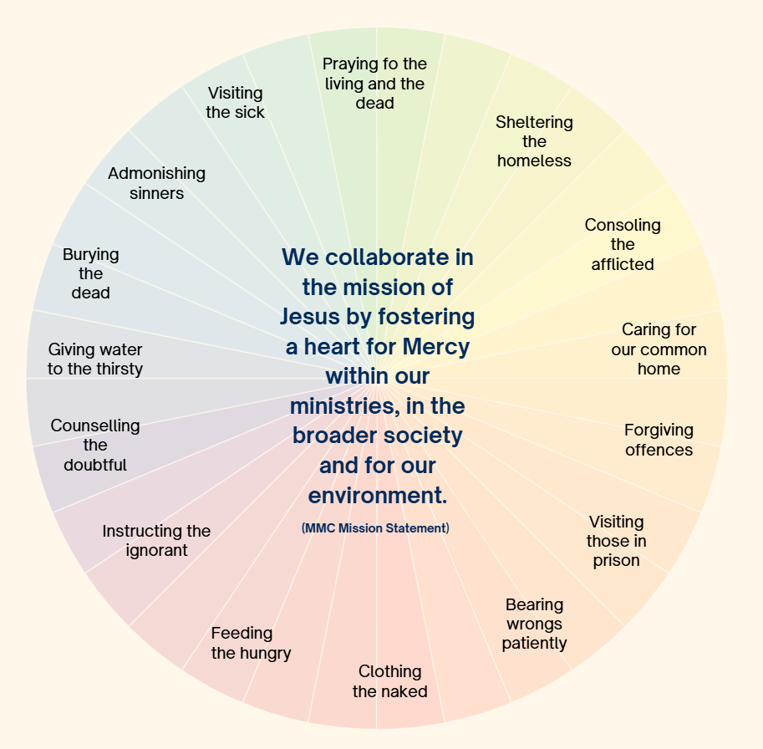
For quiet reflection and sharing
In what ways do you see Works of Mercy happening in your organization?
A Mercy Day blessing
In the words of the poet, Mary Wickham rsm, we pray for each other on this day of celebration:
“May you meet mercy each day:
In the light of your own heart, at the hands of loved ones,
In the eyes of the stranger and the needy.
And if by chance you do not at first meet it, then search your heart for it,
And it will tap you on the shoulder,
A quiet surprise, a small gesture, the tender look given and received
In the encounters of your day.”
[Mary Wickham (2006) Souvenirs of Spirit Richmond: Spectrum Publications p. 37]
Prepared by Annette Schneider rsm

