“Rolling up our sleeves …” A Resource for Mercy Day
Theme: Rolling up our sleeves as people engaged in works of mercy
Welcome to Country or Acknowledgement of Country
Organizations can use their own text. The following text is also offered.
We gather today as people of Mercy, acknowledging the original custodians of the lands on which we are each situated.
We acknowledge and give thanks for the approximately 500 First Nations of this island, their people and their culture, their care for the land, plants, animals and waterways and their generous invitation to others to share in that culture and richness through the Uluru Statement from the Heart.
May we be strengthened in our resolve to walk with them and all First Nations peoples on the journey towards reconciliation and healing.
Introduction to our theme: “Rolling up our sleeves as people of mercy”
Every year, around this time of the feast day of Our Lady of Mercy on September 24, as members of the Mercy family around the world, we take time to reflect on our identity and purpose and to celebrate the rich heritage handed down through our founders.
The first House of Mercy commenced at Baggot Street in Dublin on this day in 1827. In 2021, on September 24, the feast of Our Lady of Mercy, Mercy Ministry Companions was established as a Ministerial Public Juridic Person, so we celebrate this day for a number of reasons. Extracts from our Wisdom tradition provide some inspiration for us as we reflect on why we do what we do today when we “roll up our sleeves” as people of mercy in our organizations.
Gospel story from Matthew (Ch 25: 34-40)
Matthew begins his account of the ethical teachings of Jesus with the Beatitudes and concludes it with this final ethical teaching before the story of the passion, death and resurrection of Jesus. It is from this story that we have the tradition of the corporal works of mercy, our call to action!
“… Come, you whom God has blessed, take as your heritage the kingdom prepared for you since the foundation of the world. For I was hungry and you gave me food, I was thirsty and you gave me a drink, I was a stranger and you made me welcome, lacking clothes and you clothed me, sick and you visited me, in prison and you came to see me.
The people will say in response ‘… when did we see you hungry and feed you or thirsty and give you a drink? When did we see you a stranger and make you welcome, lacking clothes and clothe you? When did we find you sick or in prison and go to see you?’
Let us ponder the reply to their questions: ‘In truth I tell you, whenever you did this to one of the least of these sisters and brothers of mine, you did it to me…”

Pope Francis speaking to a Jubilee Audience at St Peter’s Square in the Vatican, June 30, 2016
Speaking about the practical nature of the Works of Mercy, to the people who gathered to be part of the audience at St Peter’s Square, Pope Francis referred to the Gospel story from Matthew Ch 25: 34-40. He said, of the Works of Mercy, that “they oblige us to roll up our sleeves to alleviate suffering.”
His address can be accessed below
https://www.vatican.va/content/francesco/en/audiences/2016/documents/papa-francesco_20160630_udienza-giubilare.html

Pope Francis institutes an 8th work of mercy in 2016
Traditionally, we refer to the seven spiritual and the seven corporal works of mercy. In an address for the second ‘World Day of Prayer for the Care of Creation’ in 2016, Pope Francis proposed an eighth work of mercy. He wrote:
“Obviously, human life itself and everything it embraces includes care for our common home. So let me propose a complement to the traditional two sets of seven: may the works of mercy also include care for our common home. As a spiritual work of mercy, care for our common home calls for a ‘grateful contemplation of God’s world’ (Laudato Si, 214) which allows us to discover in each thing a teaching which God wishes to hand on to us (Laudato Si, 85). As a corporal work of mercy, care for our common home requires ‘simple daily gestures which break with the logic of violence, exploitation and selfishness’ and makes itself felt in every action that seeks to build a better world.” (Laudato Si, 230-231)

Works of Mercy
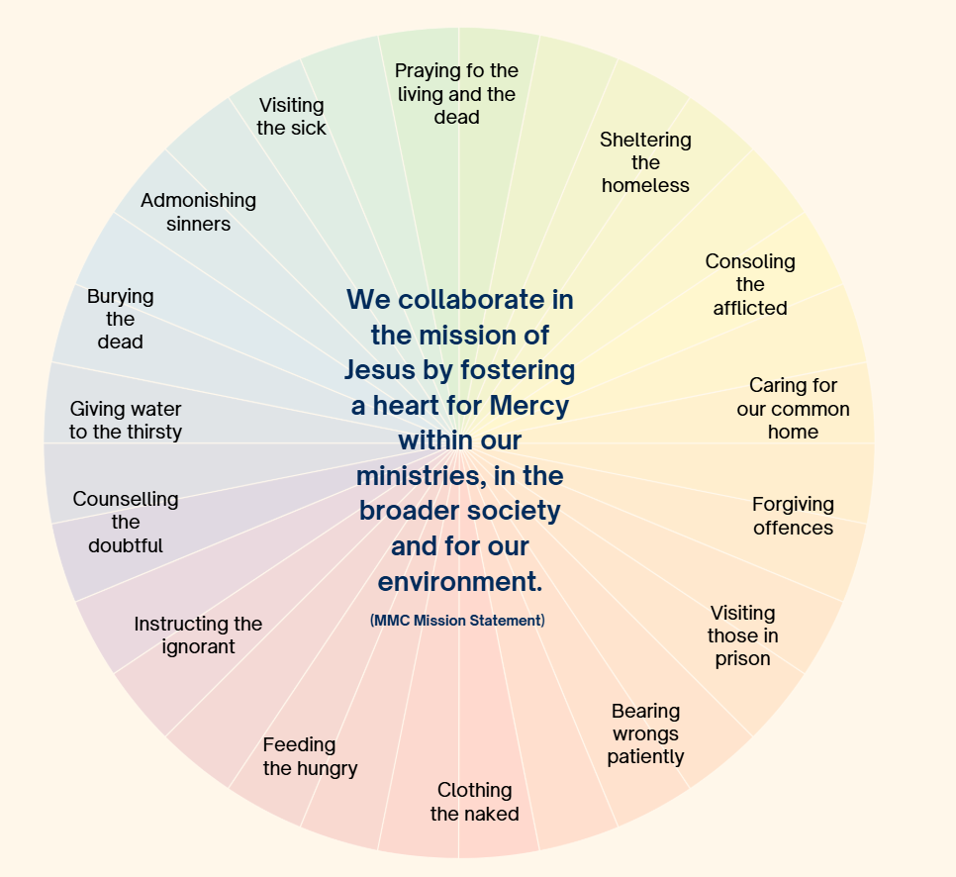

Our service of others through works of mercy
Through our compassionate and merciful responses to the needs of others, we can build up and nurture a rich ‘culture of mercy’ within our organization. Mercy is reciprocal – through our interactions with others we give and we receive mercy. There are many faces of mercy and many avenues of mercy. A Work of Mercy can be literal (such as providing water to someone who is thirsty) but it can also be figurative or symbolic (such as providing resources to someone who is thirsting for knowledge).
Reflective focus: Invite each person to reflect on how people are ‘rolling up their sleeves” and engaging in works of mercy, literally or figuratively, in their service of others.
[If people are gathered F2F, an opportunity for a brief sharing with the person nearby could be included.]
Song: Circle of Mercy [Youtube clip (5 mins 17 secs) from Mercy International Association, showing Mercy sisters and their co-workers around the world engaged in works of mercy]
https://www.youtube.com/watch?v=9NB_RwQNRYc
We pray together on our Mercy feast day
The founders of our organizations have left us a legacy, a rich tapestry of examples of ways we might respond as Jesus did to the Gospel call to love God and to love our neighbour. On this Mercy Day, we pray especially for those whom we serve and accompany, that we may be a face of mercy and compassion for each of them.
- We pray for those who struggle for the basic necessities of life – nourishing food, clean air, pure water and adequate housing:
Response: Through the efforts of our mercy family, may they experience justice and compassion.
- We pray for policy makers and law makers whose decisions affect our lives:
Response: May they make education, health and aged care, the needs of women, families and young people, and those with disability, priorities in their decision-making.
- We pray for our First Nations People who struggle for justice and recognition.
Response: May First Nations People, legislators and communities work together to ensure appropriate shelter, education, health, community services and employment opportunities can be accessed for those in need.
- We pray for all who seek better ways to care for the earth and to harness its energies for the good of all creation:
Response: May they inspire us to make our own daily gestures showing care for our common home.
- We pray for all in our community who roll up their sleeves and go about works of mercy willingly and with generous hearts:
Response: May we be attentive to and grateful for the gifts of mercy we receive through our service of others.
- We pray in silence for our own needs…
So we pray:
In the words of the poet, Mary Wickham rsm, we pray for each other on this day of celebration:
“May you meet mercy each day:
In the light of your own heart, at the hands of loved ones,
In the eyes of the stranger and the needy.
And if by chance you do not at first meet it, then search your heart for it,
And it will tap you on the shoulder,
A quiet surprise, a small gesture, the tender look given and received
In the encounters of your day.”
[Mary Wickham (2006) Souvenirs of Spirit Richmond: Spectrum Publications p. 37]
Prepared by Annette Schneider rsm

