Mercy Connect Formation Program 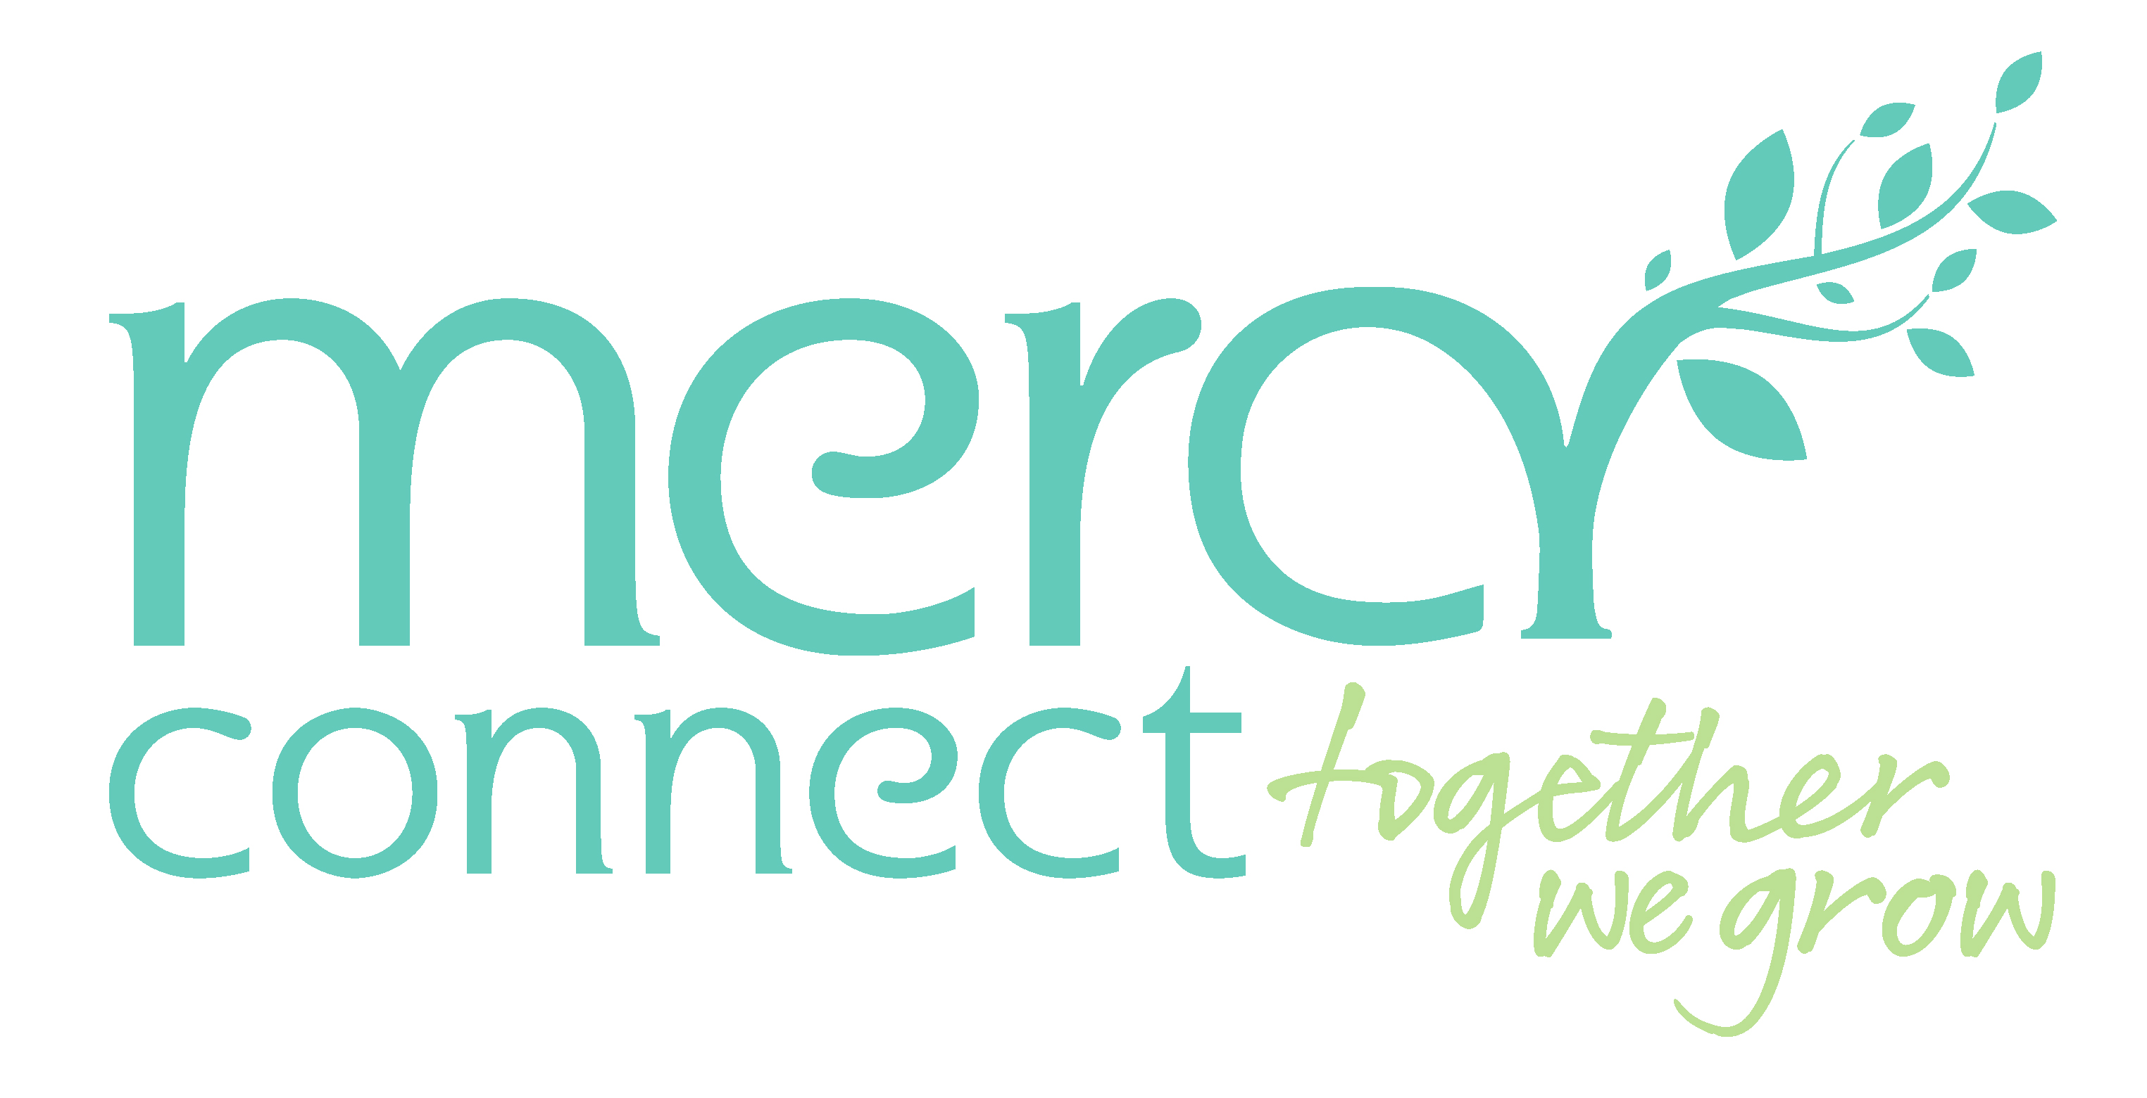
Mercy Connect’s local formation program provides practical and role-relevant opportunities for staff, volunteers and leaders to understand, live and steward the Mercy tradition. The program complements MMC formation offerings by embedding Mercy identity into induction, leadership development, cultural safety, communication, recognition and reflective practice. Formation is understood as more than training; it invites reflection, connection, discernment and action in service of people, communities and the continuing Mercy mission
Mercy Connect’s formation program can be positioned as five connected layers within the overarching Mercy Ministry Companions pathway:
1. Welcome and Orientation: Introduces Mercy identity, Catherine McAuley, the Sisters of Mercy, Mercy Ministry Companions and Mercy Connect’s local story.
2. Living Mercy in Practice: Builds practical understanding of values, expected behaviours, accountability, reconciliation and mission-aligned service.
3. Deepening Commitment: Provides structured reflection and cross-ministry learning for people leaders, emerging leaders and key influencers.
4. Stewardship and Mission Leadership: Forms senior leaders to steward Mercy identity, culture, governance and strategy in contemporary ministry settings.
5. Community Witness and Recognition: Makes Mercy visible through rituals, storytelling, partnerships, scholarships, awards and communication.

Mercy Connect Formation Program
Pathway layer | Formation element | Purpose / intended outcome | Frequency | Target group | Evidence / indicators
Welcome and Orientation | Induction and Orientation to Mercy | Introduces Mercy Connect; Mercy Ministry Companions; Catherine McAuley; the Sisters of Mercy; Mercy values; and the local Mercy Connect story. New staff are invited to connect the Mercy tradition with their role, team, and service context. | At commencement and as required | All staff, volunteers and relevant contractors | Completion recorded; staff can describe the Mercy story and how it connects to their role.
Living Mercy in Practice | Accurate Role Descriptions | Ensures position descriptions define role purpose, expectations, behaviours, accountability and contribution to Mercy Connect’s mission and values. | At recruitment; role change; scheduled review | All roles | Role descriptions include mission, values and behavioural expectations; review cycle in place.
Living Mercy in Practice | Code of Conduct and Values in Action | Defines behavioural expectations aligned with Mercy Connect and MMC values, including compassion, hospitality, respect, innovation, teamwork and accountability. | On commencement; refresher every 2 years | All staff, volunteers and relevant contractors | Completion recorded; conduct processes reference values and expected behaviours.
Living Mercy in Practice | Annual Employee Survey | Measures staff experience of Mercy Connect’s culture, values, mission alignment and leadership behaviours, and informs actions to strengthen Mercy in practice. | Annually | All staff | Survey includes mission/values items; action plans developed and communicated.
Community Witness and Recognition | Mercy Day | Provides an annual opportunity to gather, remember and celebrate the Mercy story, with local reflection on how Mercy is lived in service today. | Annually, 24 September | All staff and invited stakeholders | Participation and feedback; local stories captured and shared.
Deepening Commitment | MMC Middle Leaders Program | Provides middle and emerging leaders with cross-ministry formation, peer connection and reflective practice to strengthen mission-aligned leadership. | Annually, as offered by MMC | Middle and emerging leaders | Participants nominated; learnings shared through manager conversations or leadership forums.
Deepening Commitment | Mercy Ministry Companions Events | Enables leaders and emerging leaders to participate in MMC formation events, build cross-ministry relationships and deepen understanding of Mercy identity in contemporary ministry. | Annually and as opportunities arise | Leaders and emerging leaders | Attendance recorded; insights incorporated into team leadership and local initiatives.
Stewardship and Mission Leadership | Cultural Immersion | Supports senior leaders to deepen cultural understanding, strengthen cultural safety and connect reconciliation commitments with Mercy mission and leadership practice. | Annually, as available | Executive and identified senior leaders | Participation recorded; insights reflected in RAP actions, leadership decisions and service practice.
Stewardship and Mission Leadership | MMC Leaders Program and Dublin Pilgrimage | Enables executive leaders to experience a deeper connection with the heritage of MMC, Catherine McAuley, the Sisters of Mercy and the continuing call to steward Mercy in contemporary ministry. | Annually, as offered by MMC | Executive and identified senior leaders | Participant reflection; learning translated into strategic, cultural or governance actions.
Community Witness and Recognition | Marketing and Communications Strategy | Aligns internal and external communications, storytelling and branding with Mercy Connect’s mission, values, identity and relationship with MMC. | Annual strategy review | All audiences; led by Communications and Executive | Mission-aligned messaging; Mercy stories and values visible in communications.
Living Mercy in Practice | Regular Reflections | Creates opportunities for staff to pause, reflect and share what matters in their work, including the experiences, hopes and dignity of people supported by Mercy Connect. | Monthly or aligned with team meeting rhythms | All teams | Reflection prompts available; reflections included in meetings and gatherings.
Living Mercy in Practice | Reconciliation Action Plan Working Group | Demonstrates commitment to reconciliation in the Mercy context by embedding cultural safety, respectful relationships and practical RAP actions across the organisation. | Monthly or according to RAP cycle | Working Group members, sponsors and all staff through actions | RAP actions progressed; cultural safety learning and consultation evidenced.
Community Witness and Recognition | Shining Lamp Award | Recognises staff who visibly demonstrate Mercy Connect’s values and bring the Mercy mission to life through everyday practice. | Annually | All staff eligible | Peer nominations; award stories shared as examples of values in action.
Community Witness and Recognition | Sr Scholastica Scholarship | Extends Mercy Connect’s commitment to opportunity and education by supporting female students with their studies and strengthening community connection. | Annually | External community recipients | Scholarship awarded; impact story captured where appropriate.

